Team Charter

Due Date: Refer to due date POSTED ON BRIGHTSPACE

This template should be loaded into your shared team drive before work on it begins. All team members should participate in building all documentation. The online revision history will be referenced to ensure all team members have participated. All work must be authentic, plagiarism will not be tolerated.

Submit one Team Charter per team (File name: <<team name>> Team Charter) to the project professor via Brightspace and a link to the online document must be provided during submission.

**Submission accompanying report must contain:**

* Link to editable report on SharePoint

The Team Charter is a roadmap of how your team plans to operate.

This page as well as all informational text in italics needs to be deleted before final submission.

When the document is ready, export to pdf and each member **must** sign this digitally. Instructions on how to do digital signatures are on Brightspace. The signed version must be submitted to Brightspace. Failure to have all signatures present, will result in marks removed.

|  |
| --- |
| Team Charter  Team #1: The Best Team |
| Prepared By: Bryson Fournier, Varens Ndiongekongnana, Jacob Stoppa, Cameron Wass  Algonquin College Professor: Rama Thavasinadar  Date of Submission: 2023-05-18 |

# Table of Contents

You must use proper styles for the Table of Contents to show the correct info, you must update the Table of Contents before submitting.

CST8334 Software Development Project 1

Table of Contents 3

List of Tables and Figures 3

Team Composition and Roles 4

Mission and Objectives 4

Team Operations 4

Guide to Communications 4

Project Timeline 4

Commitment to the Charter 5

# Team Composition and Roles

Identify team members, leadership and roles. Include a picture of each team member. Identify your project professor and your team point person who will be responsible for initiating email communication with the client and the professor, when needed.

Team Member: Bryson Fournier

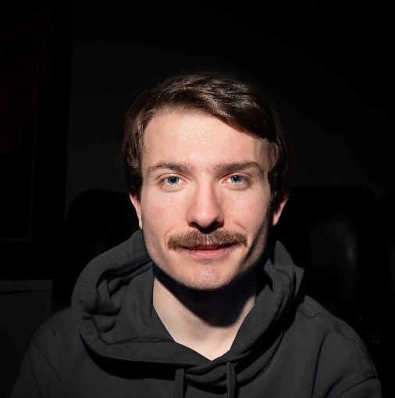

Roles:

Team Member: Varens Ndiongekongnana

<insert photo>

Roles:

Team Member: Jacob Stoppa

<insert photo>

Roles:

Team Member: Cameron Wass

<insert photo>

Roles:

Project Professor: Rama Thavasinadar

Our team leader and point person responsible for email communication is Bryson Fournier, four0224@algonquinlive.com

# Mission and Objectives

What does a successful project at completion look like? What do you hope to gain from being a team and completing a project?

A successful project looks like a complete and working application that meets the software requirements and client needs. As a team our objective is to gain project management and team working skills from this project. Skills such as delegating tasks within the team, time management, effective communication with stakeholders, and active listening are some of the major abilities we wish to attain by the completion of our project. Additionally working effectively together will allow us to enhance our programming skills in Android/for a website in order to meet deadlines.

# Team Operations

Identify the team’s commitment to:

* The number of hours of work expected of each team member per week (suggested 12 hours per week per team member).
* The days, times and locations/format scheduled for regular team meetings (at least twice weekly where attendance will be monitored).
* Name the preferred decision-making strategy (majority rules, consensus …).
* Describe the strategy for allocating work to team members.
* Describe the group rules related to lateness, absenteeism, and low participation.
* Describe one team building exercise used by the team

Number of hours expected:  
Each team member of our team is expected to dedicate 12 hours a week to this project.

Regular team meetings:

Meeting 1: Tuesday 6pm, Remote over Discord.

Meeting 2: Friday 2pm, In person/Remote at Algonquin or over Discord.

Decision Making Strategy:

Group discussion will be made to initially make decisions, if a consensus cannot be made our team will vote and majority rules.

Work Allocation Strategy:

Work will initially be allocated by giving everyone an opportunity to determine their strengths, and which tasks are best suited to take advantage of such strengths. Then the remaining tasks will be considered and allocated to the member with the most appropriate role, given everyone has even work distribution.

Group Rules:

Absence and lateness must be reported to the team via the discord channel. If proper notice is given work will be redistributed accordingly. If no notice and low participation occurs, the group will discuss further with Professor Rama.

Team Building Exercise:

# Guide to Communications

What are the methods of team communications? How often should team members update the team as to their status?

Team communications for discussion and project management related updates shall be made through the project Discord server or Zenhub. Project updates will be made on GitHub, and during team meetings. Meetings to be scheduled through outlook and the creating of Teams meetings. Team members will update during the twice weekly team meetings, and anytime a team member wishes to make a git commit.

# Project Timeline

Add key dates of sprints, demos, and final deadline that you are aware of currently.

Sprint 1 Week 1-3: May 26th 2023  
Sprint 2 Week 4-6: June 16th 2023

Prototype 1 Demo: June 16th 2023  
Sprint 3 Week 7-9: July 7th 2023

Prototype 2 Demo: July 13th 2023

Sprint 4 Week 10-12: July 28th 2023

Final Demo: August 10th 2023

Sprint 5 Week 13-14: August 11th 2023

Send Final Product to Client: August 11th 2023

# Commitment to the Charter

Replace <Team Member’s name> with the team member’s name in the same order as in section Team Composition and Roles. Include the following statement:

Team The Best Team created this charter and agree to adhere to and be accountable for following its spirit and content. Show agreement by signing below.

|  |  |  |  |  |
| --- | --- | --- | --- | --- |
|  |  |  |  |  |
| Name of Team Member |  | Signature |  | Date |
|  |  |  |  |  |
| Name of Team Member |  | Signature |  | Date |
|  |  |  |  |  |
| Name of Team Member |  | Signature |  | Date |
|  |  |  |  |  |
| Name of Team Member |  | Signature |  | Date |
|  |  |  |  |  |
| Name of Team Member |  | Signature |  | Date |
|  |  |  |  |  |
| Name of Team Member |  | Signature |  | Date |